
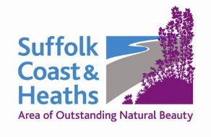
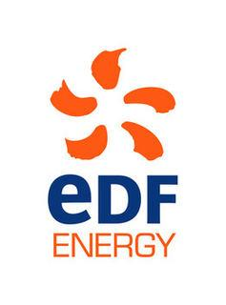
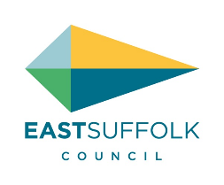

Amenity & Accessibility Fund
Projects awarded funding 2019-20

10 projects are awarded funding of total £26,780

1 Butley Ferry £2,990
Access Improvements: To improve access to the ferry at all states of the tide by raising boardwalks, lowering the ends of the jetties and constructing steps. Drawing of works supplied.

2 Aldeburgh Food & Drink Festival £1,500
Fringe Festival 2019: To support the way for a diverse range of Suffolk businesses associated with food and drink to engage with the Festivals audience, and to connect the unique landscape with the business that work within it.

3 Gill Moon Photography £3,298
Take only Photos, Leave only Footprints - a guide to photographing the Suffolk Coast: To help people explore the area through printed media, online resources and workshops.

4 Poetry People £1,850
Walking Words & Coast Lines: To create a series of video poems exploring the Suffolk Coast Path with school children from schools in the AONB area. This proposal is for sessions with a Year 4/5 class (9/10 year olds) at Aldeburgh Primary School.

5 Waveney Bird Club £3,439
Access for All Path Minsmere: Overall aim is to build an access path from RSPB’s North Wall to the East hide. Currently access is limited to people with disabilities or families with prams to enjoy this facility. This phase is for associated species and habitat surveys.

6 Art Branches CIC £2,500
Geological Layers: Environmental education project looking in detail at layers of geology 2 million, 4 million and 50 million years BC on the Suffolk Coast. Run four workshops.

7 Suffolk Punch Trust £5,000
Suffolk Heritage Garden: Ensuring the long term future of a unique Suffolk Heritage Garden. Researching and saving this Suffolk plant collection (only found at this site) for future generations to enjoy by spreading and sharing the plants to a wider audience.

8 Autism & Nature £4,723
Special School Visits: Visits for special school pupils with autism and related disabilities to places of historic and cultural interest, including Sutton Hoo and The Red House. To produce displays of follow-up work, shared with peers, parents and carers, and teachers.

9 Arabella Marshall £1,000
Wing & A Prayer: To create and install a large glass artwork into Minsmere Chapel ruin which will launch a programmes of activities for all people, encouraging a deeper connection with art, the natural environment and our local heritage.

10 GreenSnape £480
Snape Swifts: To make it affordable for residents to install 30 swift nestboxes and eight sound systems in Snape.

Cathy Smith 1 May 2019

