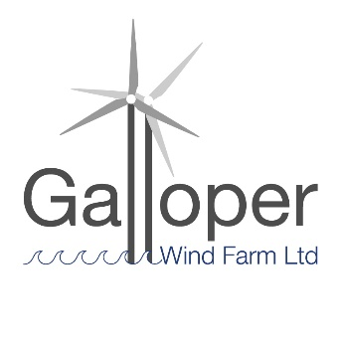
Galloper Wind Farm Fund
2021-22 projects awarded funding

Five projects were awarded £11,080

1 Leiston Community Land Trust Awarded £3,600
Leiston Church Square Community Garden:
To regenerate a redundant, neglected piece of land in the heart of Leiston, into a community garden and recreational amenity.

2 Gill Moon Awarded £673.18
Suffolk Photo Walks - Scavenger hunts with your camera:
A project to help people explore and connect with the landscapes of the Area of Outstanding Natural Beauty delivered through a series of photographic scavenger hunts.

3 Suffolk Coast & Heaths Area of Outstanding Natural Beauty & Save our Suffolk Swifts (Suffolk Wildlife Trust and Suffolk Bird Group) Awarded £1,978
Leiston Loves Swifts:
The installation of 108 swift boxes and 18 callers in Leiston, Thorpeness and Middleton to provide nesting opportunities for this dramatically declining Area of Outstanding Natural Beauty Nature Recovery Priority Species.

4 Art Branches CIC Awarded £2,324
Coastal Filming with Young Carers:
Environmental learning and filming on Suffolk’s Coast looking at geology, patterns and colours in the coastal landscape.

5 The Long Shop Museum Awarded £2,504.82
LED to the Light:
To replace all fluorescent lighting fixtures in the New Community Hub areas with low energy, low UV LED fixtures.

At 19.04.2021

