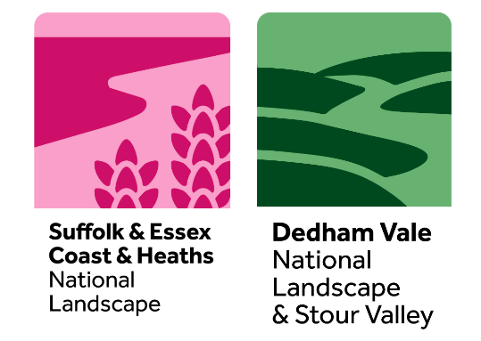
Suffolk & Essex Coast & Heaths National Landscape
Dedham Vale National Landscape & Stour Valley
Sustainable Development Fund (SDF)
2024 – 2025 Application Form

Please complete all sections of the Application Form and return by
24th May 2024, 23:59

Before taking the time to complete this form you may wish to check the criteria and guidance and ensure that your project will provide benefits to the specified geographic area of the fund.

The National Landscape wishes to attract applications from the widest range of society possible and supports equality of opportunities to access this fund. For assistance with completing your application, please contact the National Landscape Grants Officer for further support and advice.

1. Which National Landscape are you applying to? (delete as applicable)

Suffolk & Essex Coast & Heaths National Landscape / Dedham Vale National Landscape

Note - If you wish to apply to both National Landscapes for projects, please fill in separate Application Forms. Your budget should be presented separately, and you should have different National Landscape-specific objectives or activities.

2. Name of Project

3. Organisation/Group
Name of Organisation/Group
Website address

4. How much is your funding request?

£

5. Short Summary of Project (up to 30 words)

6. Contact Details
Main Contact: (address to be used for grant finance unless specified otherwise in Section 11)
Name

Address/Postcode

Phone/Mobile

Email

Additional Contact:
Name

Phone/Mobile

Email

7. Details of Project (up to maximum 2 pages of text)

Please cover the range of information indicated below.

- What is the overall aim(s) of the Project?
- Why is this project needed and by whom?
- Describe the work/activity you will be doing and who will benefit?
- Who will be involved in the project (e.g. volunteers, delivery partners, groups)?
- Is this project related to another project or is further work of a recent project?
- What is the planned outcome/what will be the finished project?

8. Location/Grid Reference or Address of Project
Enclose or attach a map, plan, or photo as necessary.

9. Project Timetable
Please provide a brief activity plan with estimated start and end dates, key event/activity dates

Note – the project should plan to begin from late July 2024 onwards and be completed by or before 13th March 2025.

10. Name of Project Manager/Leader
Please provide details of experience/qualifications relevant to the role

11. Evaluation
How will you measure the success of the project?
- How will you know it has succeeded?
- What are your measurable achievements? e.g. volunteer numbers/hours, people involved, trees planted, nest boxes installed etc.

12. Grant Payment
What type of organisation are you? A trust, charity, voluntary organisation, limited company etc.

Are you VAT registered? (delete as applicable) YES/NO

If applicable - I/We hereby request to nominate a partner organisation to provide a bank account for grant finance purposes.

Partner organisation name
Address
Contact name
Contact e mail

Note
- The fund cannot meet VAT costs for VAT registered organisations.
- Applicants need to have their own bank account for full grant payment to be invoiced from and paid into. If this is not possible, you may request above to nominate a partner organisation to provide a bank account for grant finance purposes.

13. How does the project meet National Landscape conservation objectives
(up to maximum 1 page of text)

- Does the project conserve and enhance natural beauty and maintain the special qualities of the landscape?
- Will it help manage the assets and resources of the National Landscape in a sustainable way and seek to meet environmental, economic, and social needs?
- Does it support community involvement in the active conservation and enhancement of the National Landscape?

14. Project Budget Summary
Please insert or attach a table showing your proposed budget (income and expenditure) and then complete figures a to c.

a) Total cost/value of the project
(include match funding*) -----------------------------

b) How much is already in place
(= secured match funding*) -----------------------------

c) Total outstanding amount (=a-b) -----------------------------

d) Amount of grant requested
(usually = c, however, may be a
lower amount if match funding*
has not yet been secured) -----------------------------

Notes:
- To complete this section, please refer also to Funding Criteria and Guidance Notes for Applicants 2024-25 which includes an example budget table format and values for estimated volunteer time.
- Grants are offered for up to 70% of the total project costs/value. Where a project is seeking a grant of up to £500, organisations can apply for 100% of the total costs.
- The fund cannot meet VAT costs for VAT registered organisations, therefore if you are VAT registered – please use figures excluding VAT in your project budget calculations.
- *Match Funding - A contribution from the applicant is required towards the project budget. This is known as ‘match funding’ and may include the estimated value of volunteer/staff time, in-kind contributions or other funding secured to enable the project to be completed.

15. Additional budget and funding information
Please describe the role of volunteers in the project.

How will you fund the balance (if not explained above)?

If only partial funding is available, which elements of the project would be given priority?

Note - This information is important for the Panel to be fully informed in considering the application. You may wish to describe any alternative means for your project to provide match funding* to enable the project to be completed e.g. core funds, fundraising, partner contributions, applying to other grants etc. and what would happen if you are unable to secure the remaining funds required to deliver the project.

16. Where did you hear about this grant giving programme?

Declaration:
- I have read the Criteria and Guidance and accept unconditionally the Terms and Conditions.
- I have authority from the organisation named in Section 2 to submit this project to the National Landscape for a Sustainable Development Fund grant.
- I agree that the National Landscape may make enquiries in connection with this application to satisfy itself about relevant financial and legal matters.
- I confirm that the details as set out in this application are correct to the best of my knowledge and that nothing material affecting this project has been withheld.
- I understand that my details will be stored securely for National Landscape purposes only and will not be shared externally.

Signed ………………………………………………….. Date …………………..

Name (please print) …………………………………………………

On behalf of …………………………………………………………

Please submit your completed application form by 24th May 2024, 23:59

Application by e mail is encouraged: grants@suffolkandessex-NL.org.uk

National Landscape Grants Officer
Sustainable Development Fund
Dedham Vale National Landscape/Suffolk & Essex Coast & Heaths National Landscape
National Landscape Office, Saxon House, 1 Whittle Road, Hadleigh Road Industrial Estate, Ipswich, IP2 0UF

Tel: 01394 445225

suffolkcoastandheaths.org dedhamvalestourvalley.org

OL Jan 2024

