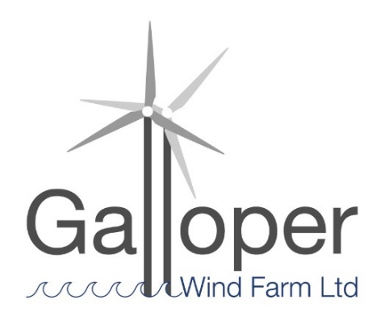
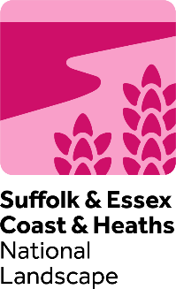
Galloper Wind Farm Fund
Publicity guidance for grant funded Projects

In the event of your project securing a grant award, your work is funded by one of the National Landscape grant giving programmes, working in partnership with a network of organisations to manage grants available to communities.
Your innovative work deserves recognition and we encourage you to strongly publicise your grant award - the National Landscape can work with you to support this. Publicity is a powerful tool to celebrate and promote the successes of your project, and for the National Landscape to monitor and evaluate grant funded projects.
The National Landscape and partners want it to be known that our funds are a part of your efforts to conserve and enhance the National Landscape and GWFF area, and so we ask that you give recognition of the funding support provided by the grant in any publicity.
This Publicity Guidance is to advise GWFF grant funded projects on:
- Conditions and expectations of the Galloper Wind Farm Fund
- Support available to your project from the National Landscape Team
- Use of logos
- Use of digital platforms

- Conditions of Offer - In acceptance of your grant award we ask that you:

- Acknowledge - Give recognition of the funding support provided by the ‘Galloper Wind Farm Fund’ in any publicity, including for your completed project. Suggested use of the following text: “This project has been [part] funded by the Galloper Wind Farm Fund” and use of the fund logo(s). Promotional Flag: for events and activities please us the outdoor flag where possible (available from the National Landscape)

- Proof read – Before releasing any publicity, please request sign-off from the National Landscape Team. Ideally this should be at least one week before any proposed promotions. This will help to ensure that the grant logos have been used correctly, allow for proof-reading and confirm that there are correct references to the grant fund before release/printing.
- Examples of publicity that needs to be signed off by the National Landscape Team are: press releases, promotional materials and publications e.g. leaflets, displays, signage, artwork, reports, newsletter articles, maps, learning resources, books, also presentations and web pages. Social media posts do not need to be signed off by the National Landscape Team but please ensure the appropriate tags in your social media post so we can support digital engagement with your project.

- Provide evidence for final claim - Your project is required to provide publicity evidence in support of your final claim as follows:

A Final Monitoring Report including:
  - Photos of the project (at least two) for publicity use with the appropriate consents in place.
  - Copies of relevant press releases and publicity, including digital coverage
  - Demonstration of measurable success of your project e.g. social media posts/publicity records/statistics.
  - If there is a lot of publicity, choose a few ‘highlights’ from each media platform.
  - Feedback or quotes from participants.
The GWFF Panel, the National Landscape and Galloper Wind Farm reserve the right to use any material submitted for publicity purposes.

- Publicity support from the National Landscape Team
Plan ahead with your publicity and recognition of the grant award. Consider writing a brief communications plan including how you are going to record and evaluate your project publicity. Share your plans with the National Landscape Team so that we are aware and can be involved in the process.
The National Landscape Team can support your project through its communication networks, so please contact us if there are any publicity opportunities for your project that we can help to maximise.
Your National Landscape Team Contacts for publicity are:
- National Landscape Grants Officer (first point of contact) - Oka Last oka.last@suffolkandessex-NL.org.uk
- National Landscape Communications Officer - Tom Fairbrother tom.fairbrother@suffolkandessex-NL.org.uk

- Use of Logos
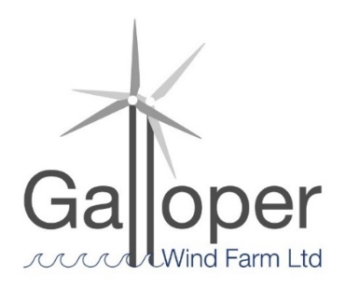
The Galloper Wind Farm logo should be used as a minimum requirement for all GWFF publicity, as shown.
Where possible, the Suffolk & Essex Coast & Heaths National Landscape logo may also be used as shown:

Please contact the National Landscape Team for high quality images if required.

- Use of digital platforms
For all digital platforms (website, e mail signatures and social media) – Write about your project, featuring the fund logo(s) and mention the ‘Galloper Wind Farm Fund’ grant support, ideally linking to the National Landscape website.
Website: www.coastandheaths-nl.org.uk
Social media links and tags:
Facebook username and Tags: @coastandheaths #GalloperWindFarmFund
Facebook link: www.facebook.com/coastandheaths
Twitter username: @coastandheaths #GalloperWindFarmFund
Twitter link: www.twitter.com/coastandheaths
Instagram username: @coastandheaths @galloperwindfarm #GalloperWindFarmFund
Instagram link: www.instagram.com/coastandheaths

