
Suffolk & Essex Coast & Heaths National Landscape
Community and Conservation Fund

Funding Criteria and Guidance Notes for Applicants 2025-26

Contents

1 What kinds of schemes are eligible?
2 Grant Amounts
3 Timeline
4 Criteria & Budget
5 Monitoring & Publicity
6 Payment
7 Terms & Conditions
8 Links

1 What kinds of schemes are eligible?
Community and Conservation Fund grants can be used for a range of purposes including:
- Enhancement schemes
- Practical conservation work
- Public access and infrastructure improvements
- Equipment purchases
- Information and interpretive material
Grants are available for both revenue and capital projects and can be used as part funding for larger projects, though evidence of funding is required in such cases.

2 Grant Amounts
The Community and Conservation Fund is the Suffolk & Essex Coast & Heaths National Landscape small grants scheme, and grants are typically awarded in the region of £500-£750.
The National Landscape has other funds available, such as the Sustainable Development Fund, with grants typically awarded for higher amounts www.coastandheaths-nl.org.uk

Grants can be awarded to fund up to 100% of project costs. Projects are encouraged to include their own contributions to the project delivery in the project budget, for example their own ‘in kind’ contributions such as volunteer time may be reflected in the budget. Up to 20% of the project value may be grant support of overhead costs e.g. staff and office costs.
See Section 4 Criteria & Budget for more. ‘In kind’ contributions may be included in the project budget.

3 Timeline & Overview

Important dates:
- Closing date for applications to be received: 3rd March 2025
- Project delivery and completion: April 2025 to 12th March 2026
Before you complete the Application Form, it is essential to check that your project benefits the fund area. If your project does not benefit the fund area it will not be eligible to receive a grant (see below ‘Geographic eligibility’) .

Complete all sections of the Application Form or there may be insufficient information for the Panel to make a fully informed decision on your proposal.

The National Landscape will acknowledge receipt of the application, inform you of when the Panel will meet and contact you after the Panel Meeting to inform you of the outcome.

Geographic eligibility:
The geographic area of the Community and Conservation Fund is the entire geographic area of the Suffolk & Essex Coast & Heaths National Landscape. You may view the geographic area of the National Landscape here: insert link (see Google Maps green shaded areas)’.

Applicants may come from within or outside the Fund area. Projects need not necessarily come from, or be based in, the Fund area. However, projects must meet the Criteria of the Fund to further the conservation and enhancement of the Fund area. An award may be made to a project located outside of the Fund area where benefit is seen to be achieved for/within the Fund area, for example (but not limited to) projects that benefits transient wildlife or enhances landscape views from the Fund area.

What makes a strong project?
Please the Suffolk & Essex Coast & Heaths National Landscape website for summaries of past grant funded projects and to read case studies. Successful applications clearly demonstrate benefits to the National Landscape and strongly meet the Criteria of the Fund. Recommended reading about the vision of National Landscapes may be found in Links Section 8.

The Government commissioned Landscapes Review of National Landscapes and National Parks (2019) identified the need to engage with a broader range of society in delivering National Landscape purpose. The National Landscapes are committed to equality of opportunities to access the CCF and seek to attract applications from the widest range of society possible.

Projects funded by the CCF will share the vision for a sustainable future, as summarised in the Suffolk & Essex Coast & Heaths National Landscape Management Plan and pledged in The Colchester Declaration (2019 The National Association for National Landscapes).

4 Criteria & Budget

Criteria:
Applications to the Community and Conservation Fund are assessed on how well they fulfil the three requirements of National Landscape designation and the aims of the Suffolk & Essex Coast & Heaths National Landscape Management Strategy, as follows:

Applications should seek to address one or more of the following:
Requirement - To conserve and enhance natural beauty and maintain the special qualities of the landscape
- Conserve landscape character and enhance the distinctive nature of the National Landscape
- Conserve biodiversity and lessen fragmentation of habitats
- Conserve the historic resources of the area including landscapes, archaeology and the built environment
- Retain the tranquillity of the area
- Conserve the geodiversity of the area
Requirement - To manage the assets and resources of the National Landscape in a sustainable way and seek to meet environmental, economic and social needs
- Suffolk tourism brand and the tourism industry based on sustainable practices

Requirement - To meet the demand for recreation where this is consistent with the conservation of natural beauty and the management of the land and to help people enjoy, understand and value the National Landscape
- Have access and recreation provision that respects biodiversity, landscape, geodiversity and historic assets
- Provide interpretation that improves understanding, guides behaviour and helps people enjoy the National Landscape
- Support community involvement in the active conservation and enhancement of the National Landscape

Budget:
Including overheads in your budget: Up to 20% of the project value may be grant support of overhead costs e.g. staff and office costs . Panels usually expect to fund project activity. Panels recognise that projects need resources to deliver them. Panels anticipate seeing overhead costs, such as staff and office costs as part of match funding, so showing up in the income and expenditure elements of the budget. In most cases the Panel will consider supporting staff and office costs at 20% of expenditure levels. (i.e. up to 20% of the overall value of the project). In some circumstances, for example where staff are brought in to deliver a particular project the intervention rate may rise to 100% of overhead costs.

Grants are offered for up to 100% of the total project costs/value, however it is beneficial for the Panel to be fully informed in their decision making in considering the application and we advise that you include match funding* in your budget.

*Match Funding - A contribution from the applicant towards the project budget. This is known as ‘match funding’ and may include the estimated value of volunteer/staff time, in-kind contributions or other funding secured to enable the project to be completed.

Voluntary and community organisations may be able to use ‘in kind’ help (e.g. volunteer time or the loan of equipment, premises or land) to form at least part of a contribution towards the overall value of the project. The Applicant should calculate ‘in kind’ contributions and include in the project budget for the Panel to be fully informed in the decision making process.
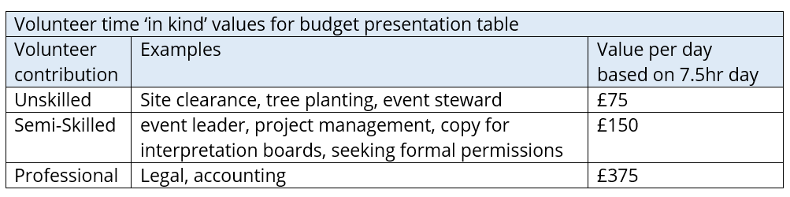
VAT:
If the application is from non VAT registered organisation/body/individual the CCF can fund up to 100% of the gross cost of the project. (i.e. VAT cost can be met by the fund). If the application is from a VAT registered organisation the CCF cannot meet any VAT costs (i.e. use figures excluding VAT).

Budget presentation:
It is vital for the Grant Advisory Panel to see the financial details of your project. Please include in your application a detailed breakdown of the expenditure and income of the project. It is important for the Panel to see how the money is likely to be spent. The Panel appreciates that some elements may be hard to cost but it is important that expenditure is not presented under large general headings or that guesses are made about costs. This is to everyone’s benefit as it would be sad to find there is not enough money to complete the project when the Panel would have been willing to offer more grant aid to a well thought out application. If estimates must be made, please indicate this on the form.

Below is an example of a table that is useful for the Panel to consider your application. It is a requirement for your budget presentation to be in a similar format, for consistency of information that is presented to the Panel across all applications.
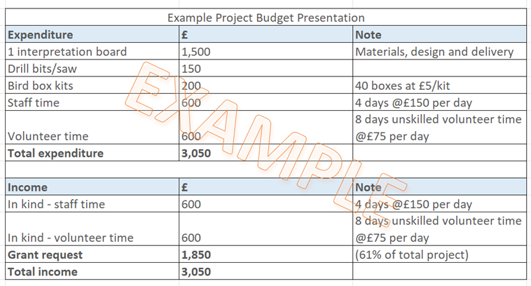
5 Monitoring and Publicity

Monitoring:
A mid-year update and a short end of year report, together with completed Monitoring Forms should be sent to the National Landscape.

The end of year report should include at least one photo of the project plus any feedback or quotes from participants that the National Landscape has permission to use in its own promotions (such as to further promote the grant giving programme in the National Landscape newspaper).

For the final claim, the National Landscape must receive an End of Grant Monitoring Form and a short Final Report by 12th March 2026 to be emailed to grants@suffolkandessex-nl.org.uk The Final Report (approx. 1 page) should include general information about the project such as:·
- An overview of achievements, including measures of success
- How CCF conditions were met - outline the main benefits of the project to the National Landscape i.e. landscape, environmental, social, economic and access enhancements.·
- Any difficulties encountered/learning points
- Number of people involved (e.g. volunteers/visitors/those using service)·
- Number of events held (if applicable)·
- Any feedback or quotes from participants that the CCF Panel and the National Landscape has permission to use in its own promotions

The final claim must also include project documentation as follows:·
- An invoice to the National Landscape for the grant payment
- Evidence to support your final claim such as:
- final project budget summary
- supporting evidence for expenditure e.g. receipts
- evidence of publicity achieved by the project
- at least two electronic photos of the project that the CCF Panel and the National Landscape has permission to use in its own promotions

Publicity:
The National Landscape reserve the right to use any material submitted for publicity purposes.

‘The Suffolk & Essex Coast & Heaths National Landscape Community and Conservation Fund’ must be acknowledged on all completed projects and mentioned in all press releases and publicity material relating to projects.

Projects must comply with the Publicity Guidance for Grant Funded Projects. This document provides guidance on:·
- Publicity conditions and expectations of the Community and Conservation Fund
- Acknowledgement of your grant award
- Mandatory use of Fund logo
- Proof-reading by the National Landscape Team of project materials/publicity before release
- Use of digital platforms
- Planning and delivery of project communications
- Support available to your project from the National Landscape Team
For further guidance on publicity requirements and support available from the National Landscape Team please see the ‘Publicity Guidance for Grant Funded Projects’

6 Payment
Projects must wait to begin publicity and delivery of the project until the formal offer letter has been received.

Applicants need to have a bank account for full grant payment to be invoiced from and paid into. If this is not possible, the applicant may request (on the Application Form) to nominate a partner organisation to provide a bank account for project purposes.

Grant money is not usually released until the end of the project and is on receipt of an invoice and a completed monitoring form. In some circumstances, up to 50% of the grant may be requested in advance, to help with issues of cash flow for smaller organisations. Before any advance payment is made, applicants will have to provide evidence that the additional resources they need to complete the project will be forthcoming and confirmation that other funding is in place.

7 Terms and Conditions:
- Applicants are responsible for management and delivery of all elements of the project, including payment of project costs and safety. All necessary permissions and procedures for the safe delivery of the project must in place. Your delivery must not conflict with any Government or other statutory body advice.
- Unless otherwise agreed in writing all projects must be completed by the following March (i.e. grants must be completed by the end of the financial year).
- Community and Conservation Fund projects must fit in with the core purpose of National Landscape designation, by enhancing the natural beauty of the landscape, improving access or benefiting wildlife.
- Community and Conservation Fund Grants must be used solely for the purposes specified in the application. Changes must not be made without receiving written approval from the Grants Panel.
- Decisions made by the Grants Panel are final and the Suffolk & Essex Coast & Heaths National Landscape is not obliged to give reasons for any decisions (although these will not be withheld unreasonably).
- Unless otherwise agreed in writing, all Community and Conservation Fund projects must be completed to the satisfaction of the Grants Panel by 13 March 2024. A short update is requested for mid term.
- Payment of a Community and Conservation grant is conditional upon satisfactory completion of the project, and evidence of this will be evaluated by representatives of the National Landscape against the information provided in the Application Form. A short report and photo evidence is requested, along with an invoice addressed to the fund.
- The National Landscape reserves the right to withhold or recover payment of all or part of any grant if the aims and objectives of the project are not fully met or if funds remain unspent. The National Landscape is open to requests for up-front financial support in special circumstances.
- The support of the Suffolk & Essex Coast & Heaths National Landscape Community and Conservation Fund must be acknowledged in any written material published by an applicant as part of, or as a result of, a Community and Conservation Fund project. This will include the use of the Suffolk & Essex Coast & Heaths National Landscape logo (where appropriate - supplied) and a suitable acknowledgement, such as: ‘This project is supported by the Suffolk & Essex Coast & Heaths National Landscape Community and Conservation Fund’
- The Suffolk & Essex Coast & Heaths National Landscape reserves the right to use any material submitted by applicants for publicity purposes.
- Project costs must be monitored and relevant accounts submitted to the National Landscape on request.

You are welcome to contact us to discuss your project prior to application, and to discuss the amount you would like to apply for.

Completed applications (preferably typed, or if not, clearly written in dark ink) should be submitted on the Community and Conservation Fund application form, by midnight on 3rd March 2025.

Submission by e mail is encouraged: grants@suffolkandessex-NL.org.uk

National Landscape Grants Officer
Community and Conservation Fund
c/o Suffolk & Essex Coast & Heaths National Landscape
National Landscape Office, Saxon House, 1 Whittle Road, Hadleigh Road Industrial Estate, Ipswich, IP2 0UF
Telephone: 01394 445225

8 Links

For more about applying to the CCF and other National Landscape grant giving programmes:
- Suffolk & Essex Coast & Heaths National Landscape Management Plan https://coastandheaths-nl.org.uk/managing/management-plan/
- National Association for National Landscapes Colchester Declaration https://national-landscapes.org.uk/the-colchester-declaration
- The Landscapes Review of National Landscapes and National Parks (the Glover Review) https://coastandheaths-nl.org.uk/managing/reference-library/landscapes-review/

Oka Last, Nov 2024

