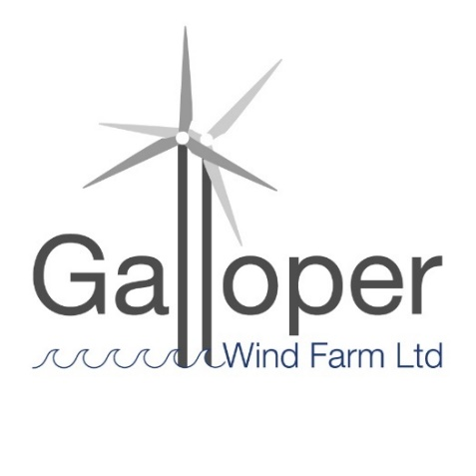

Galloper Wind Farm Fund

Administered by

Suffolk & Essex Coast & Heaths National Landscape

Funding Criteria and Guidance Notes
for Applicants 2025-2026

Contents

1 Overview
2 The Fund and its Management
3 Geographical Area for the Galloper Wind Farm Fund
____________________________

4 Galloper Wind Farm Fund Objectives
5 Essential Criteria and Galloper Wind Farm Fund Panel Priorities
6 Desirable Criteria
____________________________

7 Who can apply
8 Grant Conditions & Budget
9 Grant Management
10 Payment of Grant
____________________________

11 Monitoring & Publicity
12 Monitoring
13 Promotion & Publicity
_____________________________

14 Application Forms
15 Links

1 Overview

Important dates
- Closing date for applications to be received: 3rd March 2025
- Project delivery and completion: April 2025 to 12th March 2026

Before you complete the Application Form, it is essential to check that your project benefits the fund area. If your project does not benefit the fund area it will not be eligible to receive a grant (Section 3 Geographic eligibility) .

Complete all sections of the Application Form or there may be insufficient information for the Panel to make a fully informed decision on your proposal.

The National Landscape will acknowledge receipt of the application, inform you of when the Panel will meet and contact you after the Panel Meeting to inform you of the outcome.

Galloper Wind Farm Limited has Development Consent Order approval to build a substation and associated cabling and connection at Sizewell, Suffolk in association with its offshore wind farm. This new infrastructure will be in close proximity to the Greater Gabbard substation. The offshore cabling comes ashore at Sizewell and connects into the Galloper substation before connecting via new and existing infrastructure, to National Grid’s electricity network.

As part of this development a Section 106 agreement has been made by Suffolk County Council, Suffolk Coastal District Council (now East Suffolk Council), the Ogilvie Estate and Galloper Wind Farm Ltd. The Section 106 agreement makes provision for a fund which is agreed at £187,000 over 17 years, to be paid at £11,000 per annum to Suffolk County Council, starting in 2016, with any unallocated fund being carried over to the next year. There is no lower or upper amount for grant requests, but they are likely to be in the region of £1,500 - £2,500 per application.

What the Galloper Wind Farm Fund funds:
The fund will be used for community, conservation and access projects, within a 5km radius of the development, including Leiston and its environs, or up to the high-water mark which, in the District Council and County Council’s reasonable opinion contribute to the appearance, setting, amenity, accessibility, and enjoyment of the Suffolk & Essex Coast & Heaths National Landscape.

The Fund supports a wide range of costs, essentially, everything that is needed to complete (or develop) a project, that falls within the criteria of the grant, may be funded. The following list is not all encompassing but gives examples of what costs the GWFF may support: capital works, practical work, events, activities, training, equipment, materials, technology, interpretation, planting, publicity, contract work, professional services or staff time.

What makes a strong project?
Please the Suffolk & Essex Coast & Heaths National Landscape website for summaries of past funded projects and to read case studies. Successful applications clearly demonstrate benefits to the National Landscape and strongly meet the Criteria of the Fund. Recommended reading about the vision of National Landscapes may be found in Links Section 15.

The Government commissioned Landscapes Review of National Landscapes and National Parks (2019) identified the need to engage with a broader range of society in delivering National Landscape purpose. The National Landscapes are committed to equality of opportunities to access the GWFF and seek to attract applications from the widest range of society possible.

Projects funded by the GWFF will share the vision for a sustainable future, as summarised in the Suffolk & Essex Coast & Heaths National Landscape Management Plan and pledged in The Colchester Declaration (2019 The National Association for National Landscapes).

2 The Fund and its Management
The fund will be managed by the Galloper Wind Farm Fund (GWFF) Panel, made up of a representative from East Suffolk Council, Suffolk County Council, Leiston Town Council, and an Advisor from Suffolk & Essex Coast & Heaths National Landscape.

The GWFF Panel make decisions about grant applications with the aim of supporting projects which improve the appearance, setting, conservation, amenity, accessibility, and enjoyment of the Suffolk & Essex Coast & Heaths National Landscape and the area within a 5km radius of Sizewell. Funds will be held by Suffolk County Council, and the Suffolk & Essex Coast & Heaths National Landscape team will provide a secretariat, administer, market and monitor the fund and provide support for the development of projects amongst stakeholders.

3 Geographical Area for the GWFF
The geographical area for the GWFF is defined primarily by a 5km radius from Sizewell or up to the high-water mark. Please see the GWFF map for further details.
The GWFF panel may under certain circumstances choose to support eligible projects that operate more widely, that by their very nature necessitate a broader view. Any such project would still need to demonstrate conservation and amenity benefit for the specified geographic area according to the fund objectives.

4 Galloper Wind Farm Fund Objectives
The GWFF objectives are primarily those of the Suffolk & Essex Coast & Heaths National Landscape. Projects must demonstrate that they will deliver specific actions or objectives identified within the current, and subsequent, National Landscape Management Plan for the area (available from www.coastandheaths-nl.org.uk or on request), and by fulfilling community, conservation and access objectives.

5 Essential Criteria and GWFF Panel Priorities
The GWFF Panel is particularly keen to encourage projects that are pertinent to its key priorities. Preference will therefore be given to projects that cover one or all of the following:
- Conservation of landscape character and enhance the distinctive nature of the National Landscape and the GWFF area
- Conservation of biodiversity and lessen fragmentation of habitats
- Conservation of the historic resources of the area including landscapes and the built environment
- Conservation of the geodiversity of the area
- Provision and enhancement of access and recreation provision
- Provision of interpretation that improves understanding, guides behaviour and helps people enjoy the National Landscape and the GWFF area

It will also be useful for applicants to consider how their project meets sustainable development objectives within the National Landscape and the GWFF area:

Does your proposed project help conserve or enhance the natural beauty of the National Landscape and the GWFF area?
Economic sustainability:
Does it | Help the local economy in some way?  Generate its own income?  Attract other contributions?  Generate new or safeguard existing employment?
Social sustainability:
Does it | Develop community infrastructure?  Provide training or build community capacity to tackle things?  Provide new or improved local services?  Allow/ improve access for a wide spectrum of society?  Have support or involvement of local communities?
Environmental sustainability:
Does it |  | Help biodiversity and/or sustain distinctive landscapes?  Protect natural resources?  Involve reducing, recycling, or reusing materials?  Minimise adverse transport aspects?

Whilst the project does not have to bring equal benefit to all strands, there should be an element of help for each aspect, or certainly no adverse impact. Sustainable development is about the wise use of resources and avoids the exploitation of one strand to the detriment of the others.
Galloper Wind Farm Fund – project examples that meet the objectives:
- Projects that improve the environment, natural character and/or sense of place of the National Landscape and the GWFF area
- Projects that improve the visual appearance of the area and thereby increase the enjoyment and experience of the National Landscape and the GWFF area for residents and visitors.
- Projects that conserve and enhance the area’s natural beauty (the principal statutory purpose of the National Landscape’s designation).
- Projects that improve sustainable access to the area, particularly within 5km of the substation development.
- Projects may also include those that improve peoples’ intellectual access to the area, for example through the production of interpretation materials.

6 Desirable Criteria
A key aim of the scheme is to mitigate the impact of the Galloper substation and thereby to support communities in ways that enhance understanding of conservation and accessibility of the area, while promoting co-operation and social inclusion. Preference will therefore be given to projects that cover some or all of the following:

Demonstration of innovation or best practice
Promotion of or help implement social inclusion
Actively involve members of the community
Provide benefit to the public
Involvement or encouragement of partnership working
Complementary to key local and national strategies
Involvement of young people
Has little or no access to alternative funding sources
Lever in contributions from other sources
Provide potential PR for project and the National Landscape

This is not a comprehensive list and other activities could qualify for a grant.

7 Who can Apply?
- The Fund is open to organisations or groups from the public, private, voluntary and community sectors from within or outside the National Landscape, where projects benefit the Fund area
- Whilst applications from individuals are not precluded, there needs to be demonstrable wider public benefit and support for the project. It is expected that in most cases applications will be submitted on behalf of organisations or groups of people
- Applicants need not necessarily come from, or be based in, the National Landscape. However, projects must further the community, conservation and access objectives of the National Landscape and we would expect to see evidence of support for the project from the local area.
- Applicants need to have a bank account for full grant payment to be invoiced from and paid into. If this is not possible, the applicant may request (on the Application Form) to nominate a partner organisation to provide a bank account for project purposes.

8 Grant Conditions & Budget
Applications will be assessed by the GWFF Panel. They will look at the above GWFF objectives and criteria to judge how well the proposed project meets those aspirations. The Panel will favour projects that really grasp the concept of conservation and accessibility, and have demonstrated how they are trying to meet the criteria and priorities of the National Landscape. The Panel may advise that an offer is made for less than the full amount requested. They may also give guidance to the National Landscape Advisor to discuss certain aspects of the project with the applicant to clarify details before they give their final advice.

Including overheads in your budget: Up to 20% of the project value may be grant support of overhead costs e.g. staff and office costs . Panels usually expect to fund project activity. Panels recognise that projects need resources to deliver them. Panels anticipate seeing overhead costs, such as staff and office costs as part of match funding, so showing up in the income and expenditure elements of the budget. In most cases the Panel will consider supporting staff and office costs at 20% of expenditure levels. (i.e. up to 20% of the overall value of the project). In some circumstances, for example where staff are brought in to deliver a particular project the intervention rate may rise to 100% of overhead costs.

Grants are offered for up to 100% of the total project costs/value, however it is beneficial for the Panel to be aware of the added value of projects for communities when considering the application and we advise that you include match funding* in your budget.

*Match Funding - A contribution from the applicant towards the project budget. This is known as ‘match funding’ and may include the estimated value of volunteer/staff time, in-kind contributions or other funding secured to enable the project to be completed.

Voluntary and community organisations may be able to use ‘in kind’ help (e.g. volunteer time or the loan of equipment, premises or land) to form at least part of a contribution towards the overall value of the project. The Applicant should calculate ‘in kind’ contributions and include in the project budget for the Panel to be fully informed in the decision making process.

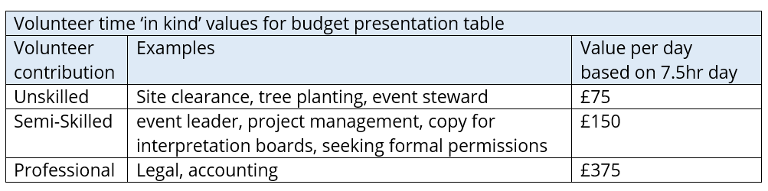

VAT
If the application is from non VAT registered organisation/body/individual the GWFF can fund up to 100% of the gross cost of the project. (i.e. VAT cost can be met by the fund). If the application is from a VAT registered organisation the GWFF cannot meet any VAT costs (i.e. use figures excluding VAT).

Budget presentation
It is vital for the Grant Advisory Panel to see the financial details of your project. Please include in your application a detailed breakdown of the expenditure and income of the project. It is important for the Panel to see how the money is likely to be spent. The Panel appreciates that some elements may be hard to cost but it is important that expenditure is not presented under large general headings or that guesses are made about costs. This is to everyone’s benefit as it would be sad to find there is not enough money to complete the project when the Panel would have been willing to offer more grant aid to a well thought out application. If estimates must be made, please indicate this on the form.
Below is an example of a table that is useful for the Panel to consider your application. It is a requirement for your budget presentation to be in a similar format, for consistency of information that is presented to the Panel across all applications.
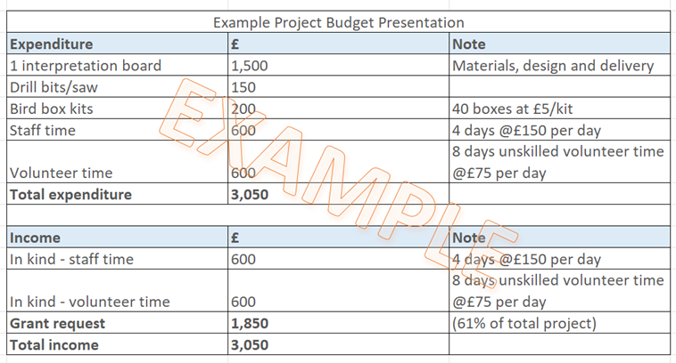
9 Grant Management
Applications will be acknowledged within five working days, and applicants will be informed of the date on which the GWFF Panel will consider their application. Applicants may in some instances be asked to provide further information to allow a decision to be taken.

The National Landscape Advisor will undertake a simple eligibility assessment and will often come back to applicants if there is missing information or they feel the project is not eligible. However, it is the responsibility of the applicants, not the National Landscape Advisor, to see that they have supplied all the required information.

Applicants will be informed within five working days of the GWFF Panel meeting whether their application has been successful, and if so the amount of grant they have been offered. This will be followed up by written confirmation and a formal offer of grant aid for successful applicants.

This will normally include certain conditions regarding:
- What the grant is supporting
- Accepting the offer of grant within a certain period
- The evidence required to prove the project has been completed that will need to accompany the claim for the grant
10 Payment of Grant
Projects must wait to begin publicity and delivery of the project until the formal offer letter has been received.

Grants are usually paid in arrears, on successful completion of the project, and by invoice being sent from the applicant. A case can be made with the application, or exceptionally when returning the acceptance of the grant offer, for money to released up front – i.e. before the project is started. This is to help with issues of cash flow for smaller organisations and can be up to 75% of the grant offer. Confirmation of receipt of other funds is also required (where relevant).

Applicants are responsible for management and delivery of all elements of the project, including payment of project costs and safety. All necessary permissions and procedures for the safe delivery of the project must in place. Your delivery must not conflict with any Government or other statutory body advice.

Unless otherwise agreed in writing all projects must be completed by the following March (i.e. grants must be completed by the end of the financial year).

11 Monitoring and Publicity
The National Landscape Advisor will monitor the progress of projects and may, if required, carry out site inspections. If this monitoring highlights difficulties with the project there may be the need for discussion and negotiation. It is the desired intention to help all projects reach a satisfactory conclusion, but the GWFF Panel will wish to safeguard the wise and legitimate use of the Fund.

12 Monitoring
A mid-year update and a short end of year report are required, and are a necessary part of the feedback to the Galloper Wind Farm Fund Panel and to Galloper Offshore Wind Farm Ltd. The grant will be paid on receipt of the final end of year report and an invoice.

For the final claim, the National Landscape must receive an End of Grant Monitoring Form and a short Final Report by 12th March 2025 to be emailed to grants@suffolkandessex-nl.org.uk. The Final Report (approx. 1 page) should include general information about the project such as:·
- An overview of achievements, including measures of success
- How GWFF conditions were met - outline the main benefits of the project to the National Landscape i.e. landscape, environmental, social, economic and access enhancements.·
- Any difficulties encountered/learning points
- Number of people involved (e.g. volunteers/visitors/those using service)·
- Number of events held (if applicable)·
- Any feedback or quotes from participants that the GWFF Panel and the National Landscape has permission to use in its own promotions

The final claim must also include project documentation as follows:·
- An invoice to the National Landscape for the grant payment
- Evidence to support your final claim such as:
- final project budget summary
- supporting evidence for expenditure e.g. receipts
- evidence of publicity achieved by the project
- at least two electronic photos of the project that the GWFF Panel and the National Landscape has permission to use in its own promotions

13 Promotion and Publicity
The GWFF Panel reserve the right to use any material submitted for publicity purposes.

‘The Galloper Wind Farm Fund’ must be acknowledged on all completed projects and mentioned in all press releases and publicity material relating to projects.

The Galloper Wind Farm Ltd logo (as shown) should be used where appropriate on materials and publicity, and is available from the National Landscape Advisor, who must also see and sign off its proposed use.

Please let the National Landscape Advisor see all drafts of printed promotion or use of logos, before anything goes to print. This will help avoid any errors in the use of the logo, any mis-spellings or incorrect ways of referring to Galloper Wind Farm Ltd. or to the National Landscape and other co-funders.

Projects must comply with the Publicity Guidance for Grant Funded Projects. This document provides guidance on:·
- Publicity conditions and expectations of the Galloper Wind Farm Fund
- Acknowledgement of your grant award
- Mandatory use of Fund logos
- Proof-reading by the National Landscape Team of project materials/publicity before release
- Use of digital platforms
- Planning and delivery of project communications
- Support available to your project from the National Landscape Team

For further guidance on publicity requirements and support available from the National Landscape Team please see ‘Publicity Guidance for Grant Funded Projects’.

14 Application Forms
Completed applications (preferably typed, or if not, clearly written in dark ink) should be submitted on the Galloper Wind Farm Fund application form, by midnight on 3rd March 2025.

Submission by e mail is encouraged: grants@suffolkandessex-NL.org.uk

National Landscape Grants Officer
Galloper Wind Farm Fund
c/o Suffolk & Essex Coast & Heaths National Landscape
National Landscape Office
Saxon House, 1 Whittle Road, Hadleigh Road Industrial Estate, Ipswich IP2 0UF
Tel: 01394 445225

15 Links
For more about applying to the GWFF and other National Landscape grant giving programmes:
Suffolk & Essex Coast & Heaths National Landscape Management Plan
https://coastandheaths-nl.org.uk/managing/management-plan/
National Association for National Landscapes Colchester Declaration
https://national-landscapes.org.uk/the-colchester-declaration
The Landscapes Review of National Landscapes and National Parks (the Glover Review) https://coastandheaths-nl.org.uk/managing/reference-library/landscapes-review/

OL Nov 2024

