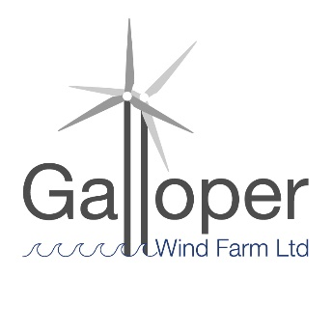**Galloper Wind Farm Fund**

**2024-25 projects awarded funding**

**Four projects were awarded £11,000**

1 Snap Skool Awarded £2,000

**Seeing the Light**

Exploring the importance and reliance we have on natural energy and light in our everyday lives and using photography as a creative tool to explore this. The 2 part workshop takes the children on a walking photography trail where they engage, connect

and capture the world around them through photography and photographic processes.

2 Leiston cum Sizewell Town Council Awarded £3,000

**Valley Road Allottment Nature Space**

To undertake the project design of a 'Nature Space' - to accompany a separate flood water management, rainwater harvesting, and the reduction of water consumption project.

3 Waveney Bird Club Awarded £3,500

**Eels Foot, Eastbridge Swift Tower – seating and interpretation**

This application is for seating and interpretation to complete the iconic Eel’s Foot Swift Tower project.

4 Alde Valley Academy Awarded £2,500

**Alde Valley Academy Sensory Garden**

This grant supports the Alde Valley Academy Sensory Garden. Lead by the pupils, the team would like to make an area of the school site more biodiverse and welcoming. Not only would this enable the Gardening Club to win a national award, it would also provide a sensory garden for children with SEN needs.

OL Nov 2024