
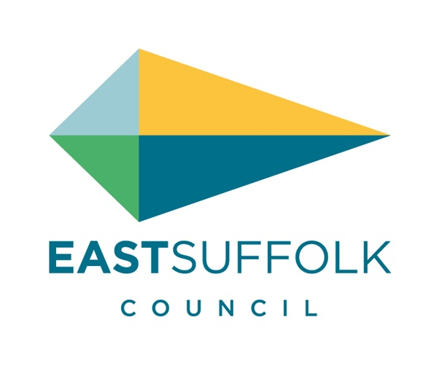



Suffolk & Essex Coast & Heaths National Landscape

Amenity and Accessibility Fund
Application Form 2026 – 2027

Please complete all sections of the Application Form and return by
9th June 2026, 23:59

Please complete all sections of the Application Form and Budget Form. Attach separately any maps, photos or drawings that you feel would support your proposal.

Equality - The National Landscape wishes to attract applications from the widest range of society possible and supports equality of opportunities to access this fund. For assistance with completing your application or any further questions, please contact the National Landscape Grants Officer,

1. Geographic Eligibility Check
Check your project is within/benefits the fund area here: pink area highlighted on the fund map
If you need an alternative map format please contact the National Landscape Grants Officer, Oka Last for support: grants@suffolkandessex-NL.org.uk or call 01394 445225.

2. Location of Project
3. How much is your funding request?
£

4. Name of Project
5. Short Summary of Project (max 30 words)
6. Organisation/Group
Name of Organisation/Group

Type of organisation e.g. A trust, charity, voluntary organisation, limited company

Website address

7. Contact Details

Main Contact - address to be used for grant finance unless specified otherwise in Section 8
Name

Full address

Phone

Email

Additional Contact
Name

Phone/Mobile

Email

8. Grant Payment - The fund cannot meet VAT costs for VAT registered organisations.
Is the applicant VAT registered? YES/NO

If applicable - I/We hereby request to nominate a partner organisation to provide a bank account for grant finance purposes.

Partner organisation name

Is the Partner organisation VAT registered? YES/NO

Full Address

Contact name

Contact email

9. Details of Project (please keep brief - max 250 words)

Cover information you feel is most relevant, you may wish to include:
- What are the overall aims of the project and how do these meet the fund criteria?
- Describe the work/activity you will be doing and who will benefit.
- Who will be involved in the project? e.g. volunteers, partners, engaging particular groups
- What is the planned outcome/what will be the finished project?
- Is this project related to another project or is further work of a recent project?

10. Project Timetable
Please provide estimated project start and end dates, with key event/activity dates
- Note the project should begin from July 2026 onwards and be completed by 10th March 2027

11. Name of Project Manager/Leader
Please provide details of experience/qualifications relevant to the role

12. Evaluation
How will you know your project is a success?
- Include simple ways you will measure achievements to show the project has met the planned outcomes e.g. volunteer hours, people involved, trees planted, nest boxes installed etc.

13. Project Budget

Complete the BUDGET FORM which is provided in an Excel template.

For help with this - see Criteria and Guidance for Applicants and please do get in touch with the National Landscape Grants Officer for support or if you need a different format of the form.

Attach the completed Budget Form separately.

14. If only partial funding is available, how will you fund the balance?
Describe any alternative funding that may be available to your project
e.g. core funds, fundraising, partner contributions, applying to other grants etc.

15. What would happen if you were unable to secure the full amount of funds required to deliver the project?
Which elements of the project would be given priority?

16. Where did you hear about this grant?
17. Declaration

- I have completed all sections of the Application Form and attached separately one completed Budget Form.
- I have read the Criteria and Guidance and accept unconditionally the Terms and Conditions.
- I have authority from the organisation named in Section 6 to submit this project to the National Landscape for an Amenity and Accessibility Fund grant.
- I agree that the National Landscape may make enquiries in connection with this application to satisfy itself about relevant financial and legal matters.
- I confirm that the details as set out in this application are correct to the best of my knowledge and that nothing material affecting this project has been withheld.
- I understand that my details will be stored securely for National Landscape purposes only and will not be shared externally.

Signed
Date

Name (please print)
On behalf of

Please return your completed Application Form by 9th June 2026, 23:59

Application by email is encouraged: grants@suffolkandessex-NL.org.uk

Oka Last, National Landscape Grants Officer
Amenity and Accessibility Fund
National Landscape Office
Saxon House
1 Whittle Road
Hadleigh Road Industrial Estate
Ipswich
IP2 0UF

Tel: 01394 445225

suffolkcoastandheaths.org dedhamvalestourvalley.org

OL Oct 2025

